

**UNIVERSITY OF PETROLEUM & ENERGY STUDIES**

**Dehradun**

**CONTINOUS INTEGRATION**

**AND**

**CONTINOUS DELIVERY**

**Experiment-14**

**Name: Aakarshit Agarwal**

**Course: B. TECH CSE DevOps (2018-22)**

**Roll no.: R171218001**

**Sapid: 500067782**

**Experiment-14**

Step 1: Create the Docker file for building the image

Step 2: Build the Static HTML image

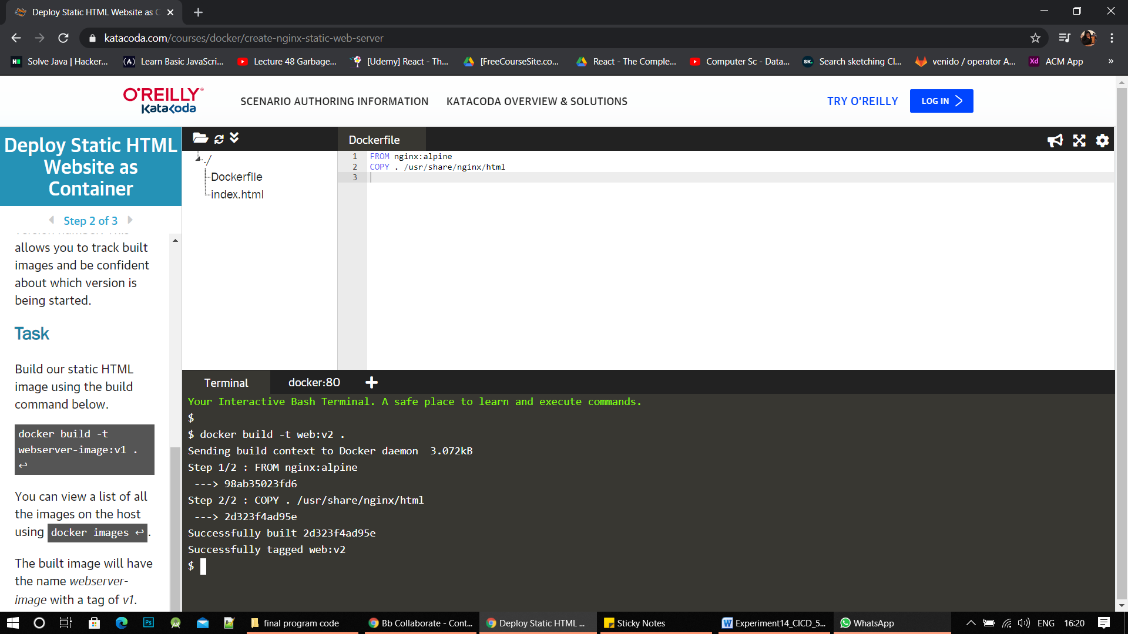

Step 3:Run the command Docker images to view all the local images

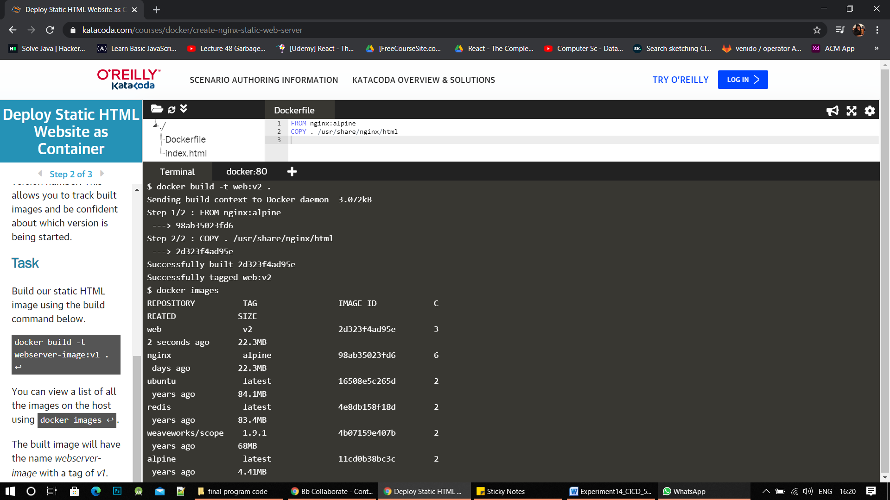

Step 4:- Run the image by using docker run -d -p 80:80 image_name

Step 5:- login into your dockerhub account using docker login –username

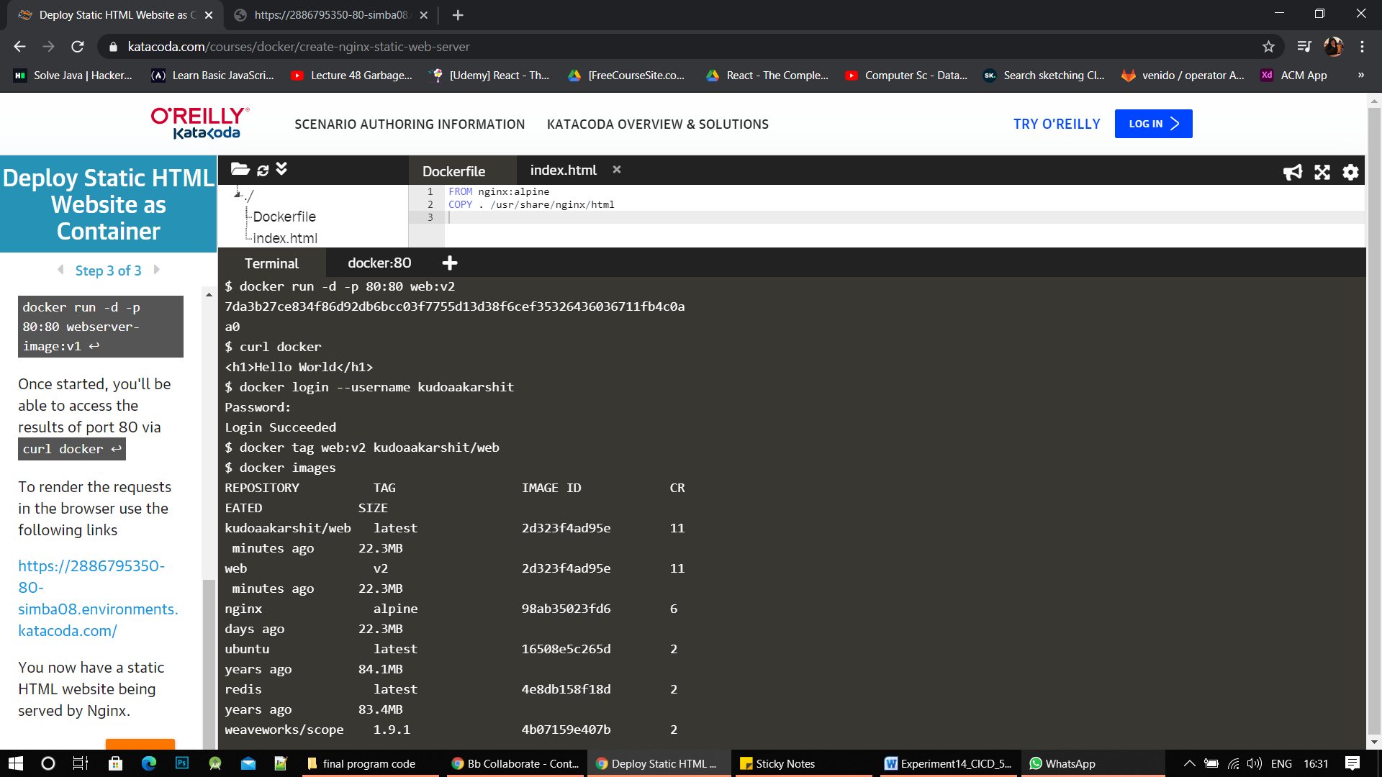

Step 6:-

Tag & push the image to docker hub using the commands

i>Docker tag image_name user_name/image_name(to be hosted)

ii> Docker push image_name



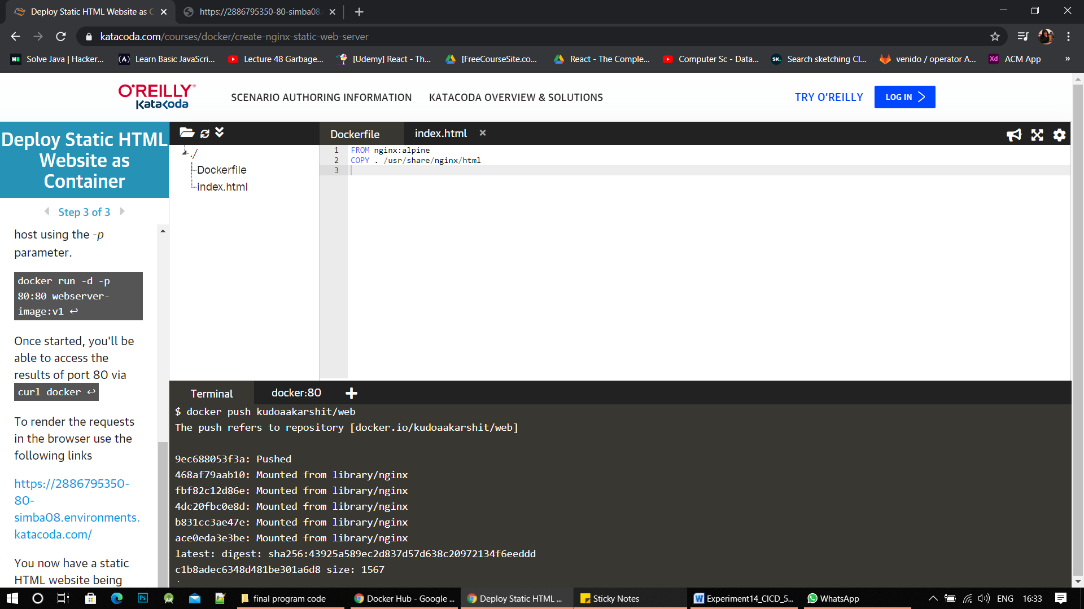

Step 7: Browse the docker hub account the image would be hosted there

